Community Instructions – Systems Strengthening for ECE Community
To Log In or Create an Account:
- Go to Home - Early Childhood Development Action Network (connectedcommunity.org)
- Create an account, or log in
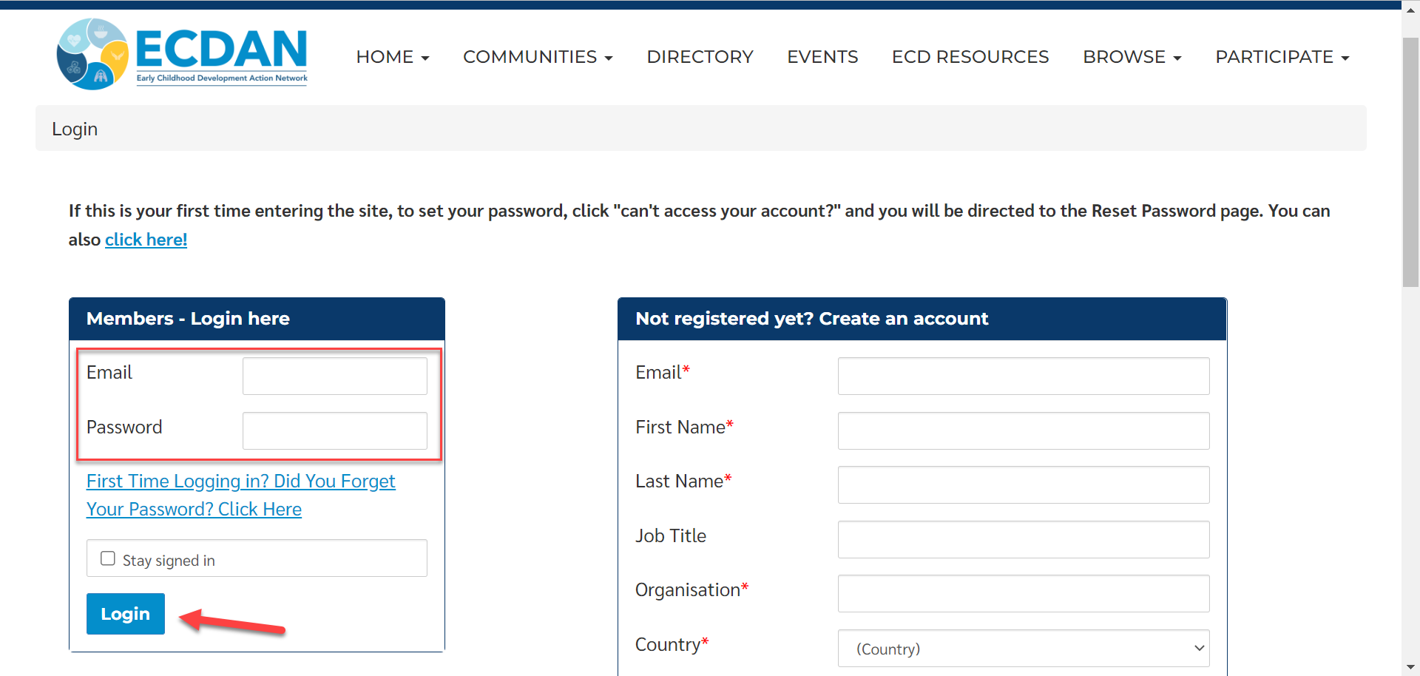
To Visit the Community
- Click Communities > All Communities
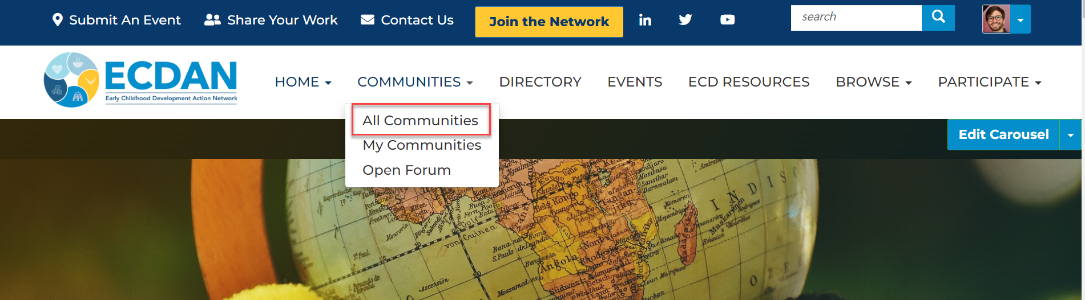
- Select Systems Strengthening for ECE Community > Join Community
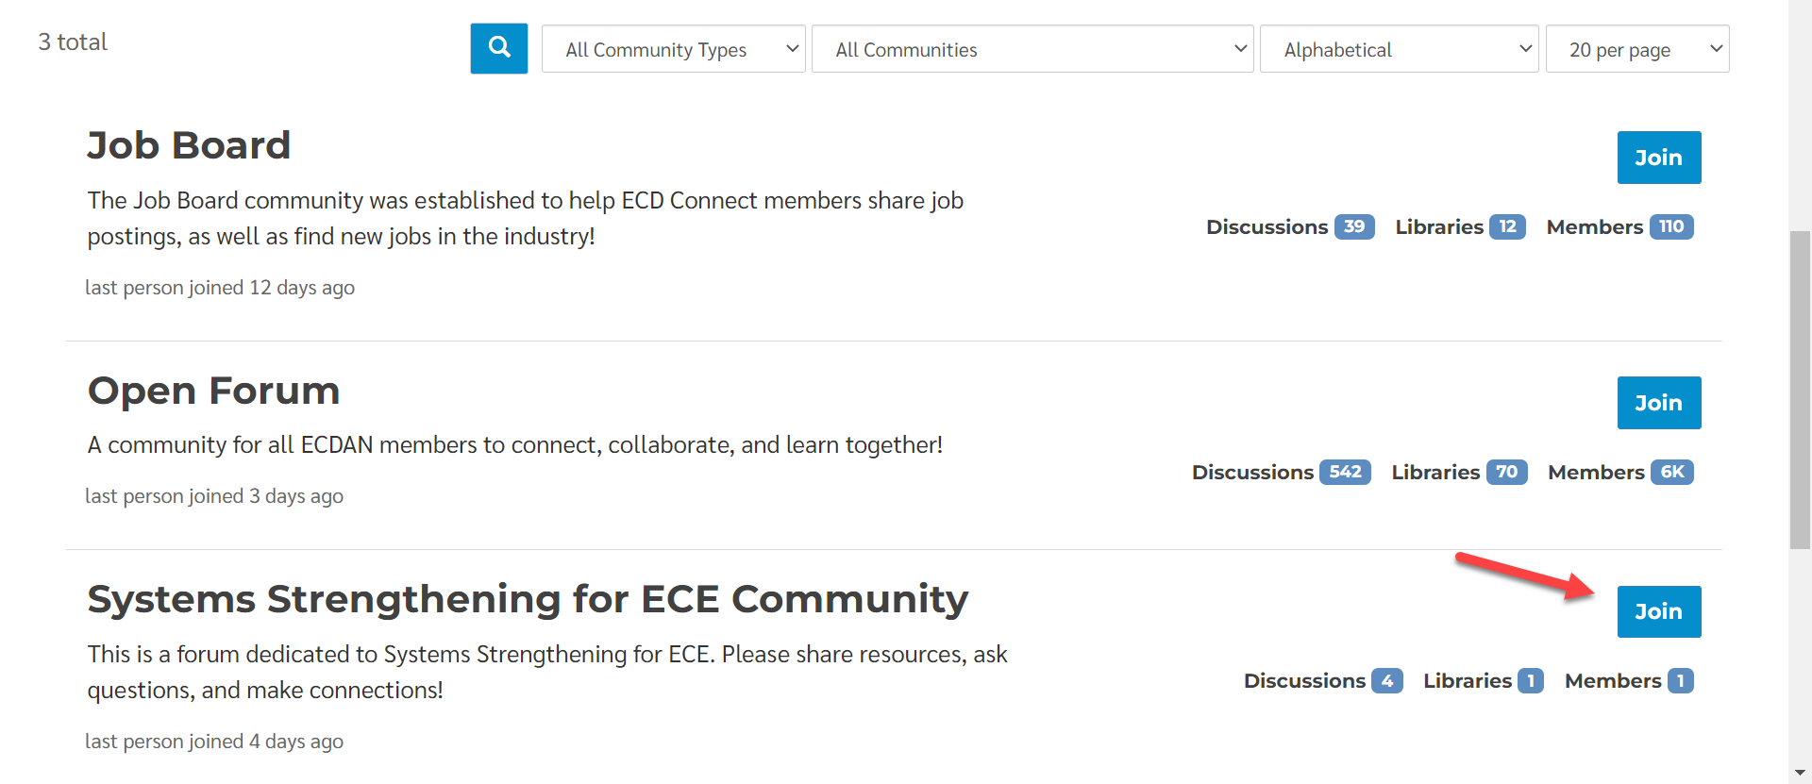
- Select your digest (community notification) settings
  - Real Time – Receive an email update every time there is new activity in the community
  - Daily Digest – Receive a daily update of all the activity in the community (best option)
  - No Email – You will not receive notifications from the community
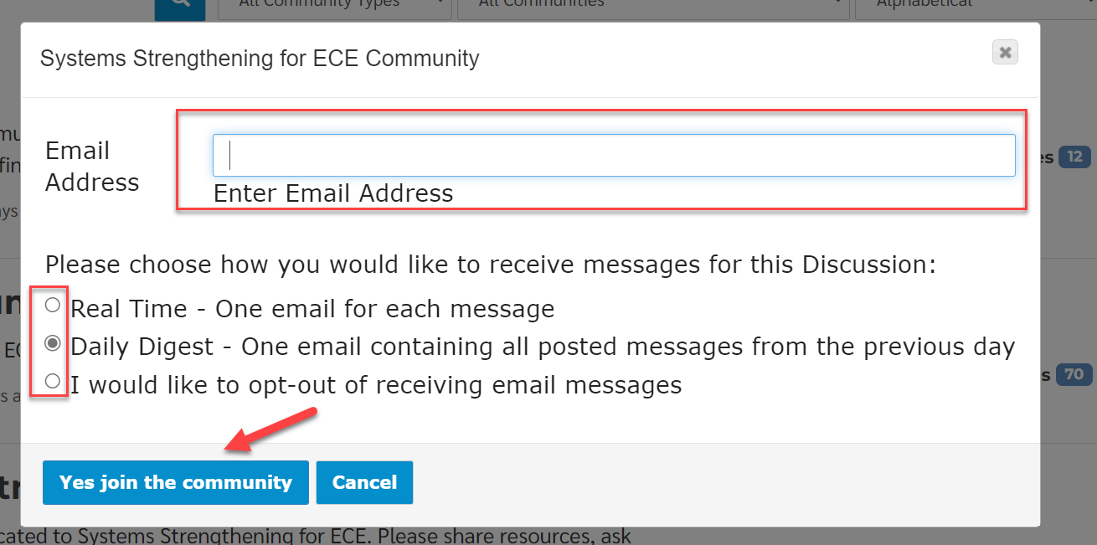
To Engage in the Community
- Add a comment by selecting “Reply” and “Post”
- Start a new discussion by clicking “Add”
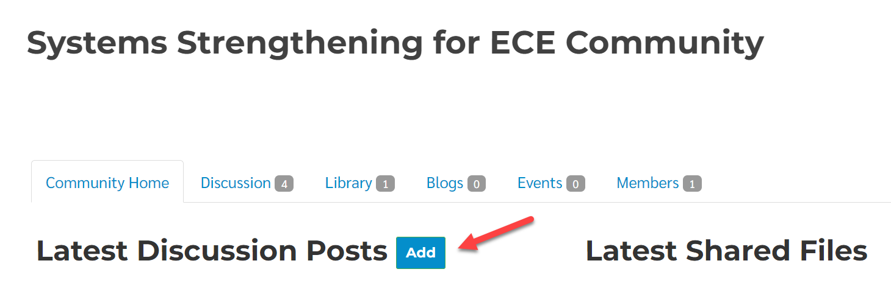
- Share a document by clicking “Add Attachment,” then drag-and-drop a document in the box.
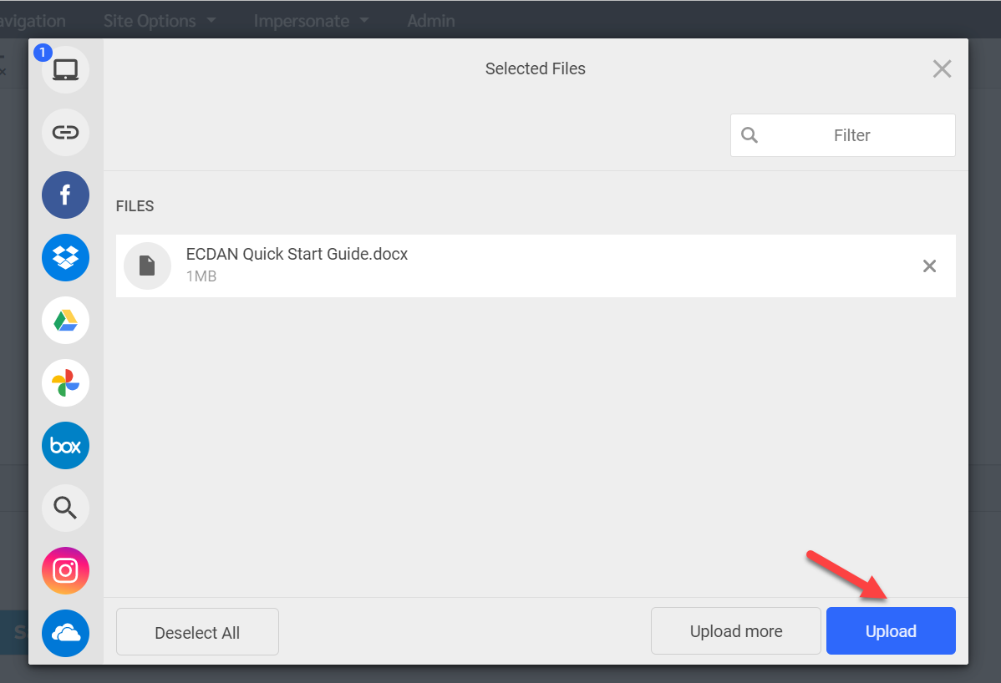
- Select “Upload” and “Post”
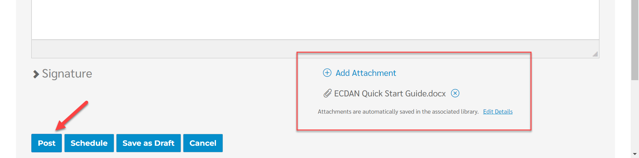

To Update Community Notifications
- Update Community Notification in your Profile by selecting “My Account” and “Community Notifications”

